//Subtract product and sum of digits of an integer
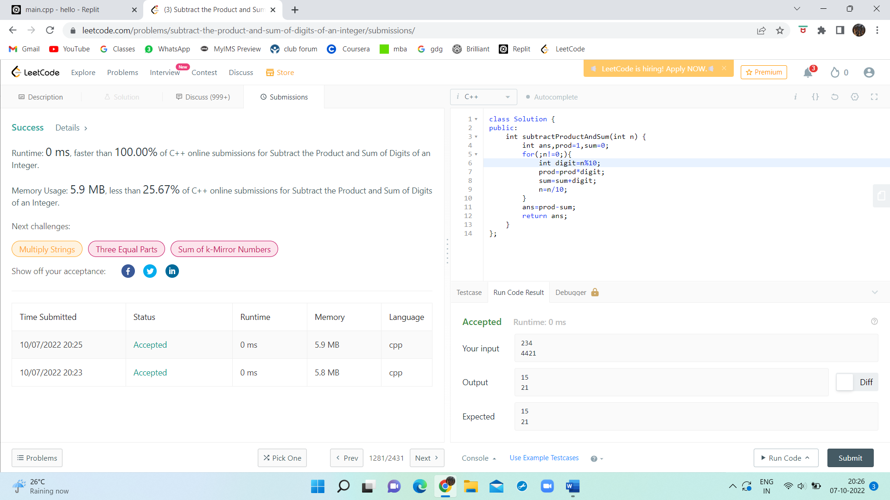
class Solution {
public:
int subtractProductAndSum(int n) {
int ans,prod=1,sum=0;
for(;n!=0;){
int digit=n%10;
prod=prod*digit;
sum=sum+digit;
n=n/10;
}
ans=prod-sum;
return ans;
}
};

